**JUNIPER Tool**

This tool help automation developer generate step faster by using GUI or load steps from MTP document. User can add the block code that was usually to render step faster. Also help the developer format the indent and re-index step unique for their test case(in YAML format).

Load all the keywords that be written earlier by other dev, and now we can reuse them. Tool will automatic notify when found new change.

1. **Login and Authentication**

* Login to use this tool

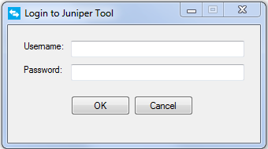

1. **Add step, or generate step from MTP file to YAML testcase**

* Help to generate step using GUI or read from MTP file doc.
* Support: Move up, down, delete, reload, copy and update step.
* User can add the block code that was usually use -> call “common step script”, ex: no-coredumps

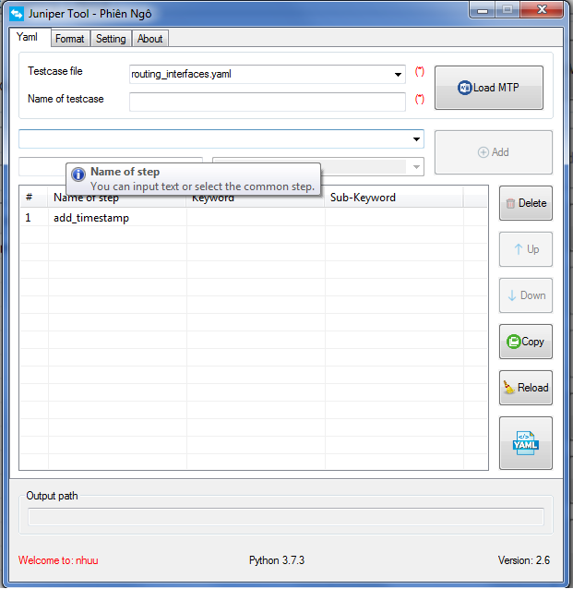

1. **Format and re-index Unique step of YAML**

* Support format indent, remove and and blank line to separately between test cases
* Re-Index by file name, this number can be modified in config.json file

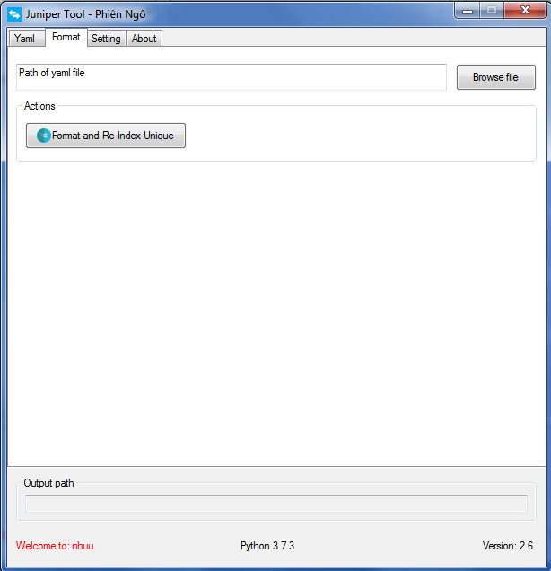

1. **Setting, read Agni keywords**

* User can be setting for Open output when done.
* Reload new keywords from your Agni directory.

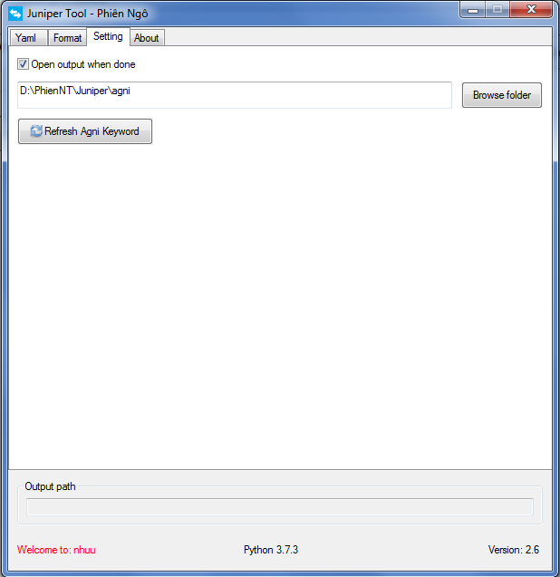

1. **About**

* User can be upgrade this tool by click Upgrade button. This tool will automatic enable “Upgrade” button when found the new change and otherwise.

